Aplicaciones Ofimáticas (Office Applications)  
Unit 02. Individual and Collective Organization with ClickUp

short line

Authors: Carmen Hompanera, Sergi García

Updated September 2022

Licence

**Recognition- No comercial - ShareAlike**(BY-NC-SA): Commercial use of the original work or possible derivative works is not allowed, the distribution of which must be done with a licence equal to that which regulates the original work.

Nomenclature

Throughout this unit, different symbols will be used to distinguish important elements within the content. These symbols are:

📖 **Important**

❕ **Attention**

💬 **Interesting**

**INDEX**

**Introduction** **3**

**Project management** **3**

**Previous concepts** **3**

**How do we develop a project?** **4**

**Could the individual organization be a project to manage?** **4**

**Kanban boards** **4**

**ClickUp Tool** **5**

**What is ClickUp?** **5**

**Useful information for working with ClickUp** **6**

**What goes in for exam?** **6**

Unit 02. Individual and Collective Organization with ClickUp

# Introduction

In this unit, we will deal with how to organize ourselves both individually and collectively with ClickUp. To do this, we will see some theory about project management, from the point of view that organizing ourselves, both individually and collectively, is like working on a project. After that, we will see the concept of the Kanban board and how to apply the organization issues through the ClickUp tool.

# Project management

## Previous concepts

Before starting, we will define these three concepts:

* **Project**: A project is a planning, which consists of a set of activities to be carried out in coordination with each other, in order to produce certain goods or services capable of satisfying needs or solving problems, within the limits of a budget and a period of time.
* **Project Management**: It is the coordination of the processes, tools, equipment, resources and times that will take part in the development of the project.
* **Project manager:** is a person who has overall responsibility for the successful initiation, planning, design, execution, monitoring, control, and closure of a project.

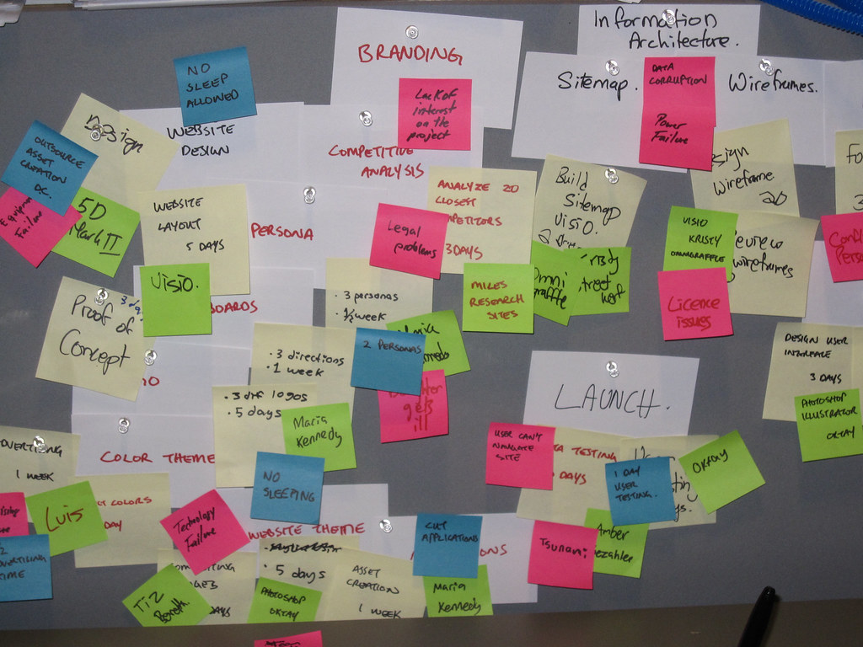

## How do we develop a project?

When developing a project, we must answer these four questions:

* **WHAT are we going to do?**
  + We must define the objective or objectives that we want to achieve with our project, for example, publicize our product, teach how to make a paella, create a product, make a risk prevention plan, etc.
* **HOW are we going to do it?**
  + We will carry out the planning of our project, defining the path to follow to achieve our objective, as well as the tasks or work to be carried out.
* **WHO is going to take care of it?**
  + Once we have the tasks to perform, we must assign them to the people on our team.
* **WHEN each thing is going to be done?**
  + We will create the calendar of our project, we will see the times of completion of each task, when it starts, when it ends and which tasks are dependent on others.

📖 **Important:** It is important to point that the organization of any project must be flexible, because unforeseen events or problems may arise along the way and that can cause us to change elements, rethink decisions and/or move our calendar.

## Could the individual organization be a project to manage?

We have included this point in order to make it easier for you to relate project management with the individual organization (that you organize yourselves) and the collective organization (that you organize yourselves together).

Individual organization (for example, writing down homework, exam dates, homework, important events, etc.) could simply be considered as a project "of our life" where we manage it ourselves, being the "project manager".

The collective organization (where several individuals are organized), is already, by definition, a management of a project. In some cases, it may have a difference, such as not having "Project manager" or everybody being "Project managers".

# Kanban boards

Kanban is a Japanese word made up of Kan, which means visual, and Ban, which means card. Therefore, Kanban refers to visual cards.

It is a visual method of project management that allows teams to visualize their workflows and workload. It is a board that is organized by columns, where the tasks and their status are displayed. More information in <https://es.wikipedia.org/wiki/Kanban>

We have different models that adapt to our needs, so we have the generic board with which we are going to work and others.

**Generic Board**

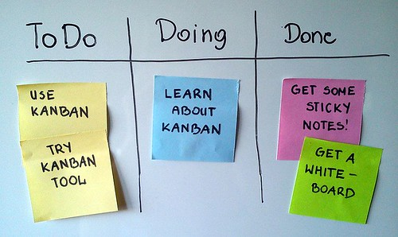

**Specific to a project**

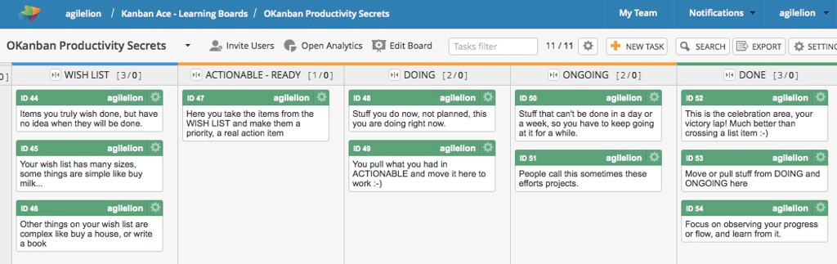

📖 **Important:** Kanban boards are useful for project management, but can also be useful for individual and collective organization.

# ClickUp Tool

## What is ClickUp?

Clickup <https://clickup.com> is a tool for managing projects and tasks. It works for all kinds of teams, and the same app can be used to plan, organize, and collaborate. This tool offers us documents, reminders, objectives, calendars, schedule planning, etc.

The tool is developed for both managers and work teams who want to work in a more organized, intelligent and efficient way with a platform that helps them manage their project.

Therefore, we can summarize that it is a Project Management software, a simple and intuitive platform for project and time management. Its main characteristics are:

* Allows registration on your website for free.
* Possibility to invite more collaborators to your project.
* It allows you to organize your workspaces.
* Add labels with which you will take control of your spaces.
* You create your tasks, define who will carry out that activity and their delivery times.
* You have different views.
* You can add all the projects you want.

## Useful information for working with ClickUp

Here are some useful links to help us work with ClickUp:

* Introducción a ClickUp: <https://youtu.be/Sy2p7-GjGEI>
* ClickUp y su jerarquía de trabajo: <https://youtu.be/SIBCJ63YPFw>
* ClickUp organiza tus proyectos y tareas: <https://youtu.be/CBuhH_LF0yk>

# What goes in for exam?

We call this section like that because for students it is always more attractive than “What should I learn in this subject?” :D Next, we indicate what you should prepare for the exam:

* Know the basic concepts of project management.
* Know what a Kanban board is.
* Being able to create and manage a Kanban board (learned during practices).
  + It can be either a “paper” Kanban board or one with ClickUp.
* Being able to organize individually and collectively with ClickUp (learned during practices).
* Being able to manage projects with ClickUp (learned during practices).